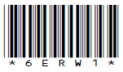

請把電腦條碼貼在方格內
Please stick the barcode label in the box.
6 | E | R | W | 1

TSA Practice Paper 1

Reading and Writing

Instructions:
學生須知︰

1. Stick barcode labels on pages 1, 3, 5, 7 and 9 in the spaces provided.
在第1、3、5、7 及9頁的適當位置貼上電腦條碼。

2. There are 23 pages in this Question-Answer Booklet. Answer all questions.
本卷共有23頁，全部題目均須作答。

3. Do not write in the margins.
請勿在框線以外書寫。

4. Time allowed is 50 minutes.
評估時限為50分鐘。

6. Write your School Code, Class and Class Number in the boxes below.
在下面的方格內填寫學校編號、班別及班號。
Instructions for answering questions:
作答說明：
Multiple Choice Questions － Blacken the circle next to the correct answer with an HB
pencil. For example :
選擇題 － 選出正確的答案，並用HB鉛筆把該選項的圓圈塗黑和塗滿，如：
 A.
 B. or A. B. C. D.
 C. 或
 D.

School Code  學校編號 |  |  |  |  | Class  班別 | 6 |  |  | Class No.  班號
此格只許填寫一個大楷英文字母
Write one capital letter in this box.
Part 1
A bookshop is conducting a survey of their children customers.
Read the charts.

Chart 1  Time spent on reading in a week  no more than 2 hours  2–5 hours  5–10 hours  more than  10 hours | Chart 2  Money spent on reading in a week  less than $50  $50–$100  $101–$200  more than $200
Chart 3  Children’s favourite book type  Cookbooks  Science  Books  Comics  Fictions  Detective Stories | Chart 4  Mong Kok  Sha Tin  Tuen Mun  Most popular branch  Causeway Bay  Tsim Sha Tsui

Part 1A
Brian is writing some notes about the information on the charts.

請把電腦條碼貼在方格內
Please stick the barcode label in the box.
Help him complete his notes.

Survey on Reading Habits

- Money spent on reading:
smallest no. of people

→ → →
largest no. of people

- Favourite branches:
Order | Branch
1 (most popular)
2
3
4
5 (least popular)

Part 1B
Choose the best answer by blackening the circle.

- Most children spend ________ hours on reading per week.
 A. less than two
 B. between two and five
 C. between five and ten
 D. over ten

- The bookshop should get more space for ________.
 A. cookbooks
 B. fictions
 C. science books
 D. comics

- Science books are more popular than ________
 A. fictions
 B. detective stories
 C. cookbooks
 D. comics

- Children like reading fictions as much as reading ________.
 A. comics
 B. detective stories
 C. cookbooks
 D. science books

- How many children buy books in the New Territories?
 A. 10%
 B. 25%
 C. 40%
 D. 50%

- Which of the following is correct?
 A. Not many children like reading comics.

請把電腦條碼貼在方格內
Please stick the barcode label in the box.
 B. A large number of children spend more than eight hours per week on reading.
 C. Most children spend less than 5 hours on reading per week.
 D. Many children spend over $100 buying books per month.

Part 2
Brian sees a poster in the school library.
Read the poster.
Popular Primary School
Come and join the Book Report Competition!

Categories and rules:

 | Number of reports per pupil | Number of words  per report
Junior (P1-P3) | no more than 2 | 200-300
Senior (P4-P6) | no more than 3 | 300-400

Students can get the book report forms from the school library from 25th September onwards. Only book reports written on the forms will be accepted.

Prizes:
1st prize $1,000 book coupon
2nd prize a one-year subscription to Happy Kids Monthly Magazine
3rd prize Happy Kids stationery set
The winning book reports will be published in the winter issue of the school magazine.

Deadline: 24th October

Interested students can contact Miss Sarah Wong for more information or browse our school website: www.popularschool.edu.hk

Results will be announced on 15th November and the prize presentation ceremony will be held on our Open Day on 3rd December.

Choose the best answer by blackening the circle.

請把電腦條碼貼在方格內
Please stick the barcode label in the box.
- Brian is in class 5A. He can write his book report in ________ words.
 A. 250
 B. 350
 C. 450
 D. unlimited

- Brian’s sister, Jenny, is in class 3C. She can write ________ book reports at most.
 A. 2
 B. 3
 C. 4
 D. 5

- If Brian wins the second prize, he will get ________.
 A. 1 magazine
 B. 6 magazines
 C. 12 magazines
 D. 24 magazines

- If Brian wins the third prize, he will get ________.
 A. books and magazines
 B. forks, knives and spoons
 C. pens, pencils, rulers and erasers
 D. a T-shirt, a jacket and shorts
- If Brian wins the competition, he will see his book report in the school magazine in ________.
 A. April
 B. June
 C. August
 D. November

- Brian can write his book report ________.
 A. on the school website
 B. in his exercise book
 C. on a poster
 D. on a book report form

- Brian can submit his book report on _____________.
 A. 5th October
 B. 25th October
 C. 14th November
 D. 1st December

- Where can students get the book report forms?
 A. the school website
 B. the school library
 C. Miss Sarah Wong
 D. Happy Kids Monthly Magazine
Part 3
Brian is reading an article in a magazine.

請把電腦條碼貼在方格內
Please stick the barcode label in the box.
Read the article and answer the questions.
Ligers

Have you heard of ligers before? A liger is a mixed animal. It has a lion father and a tiger mother. It is the largest animal in the cat family. Most ligers weigh around 320 kg, which is about the weight of five human adults.

Ligers have the characteristics of both lions and tigers. Like lions, ligers like socialising in groups. They also enjoy swimming as much as tigers do. A liger has the appearance of a lion, but with a body pattern like a tiger. An interesting fact is that ligers do not stop growing after they are born.

The largest liger in the world is called Hercules. It lives in an animal theme park in Miami. With a weight of 410 kg, Hercules is also the largest living animal in the cat family on earth! It has appeared on many TV shows in America.

It is hard to find ligers in a natural environment because lions and tigers rarely live in the same habitat. Ligers are mostly born in zoos.

Another mixed animal is tigon. A tigon has a tiger father and a lion mother. However, the survival rate of tigons is exceedingly low.

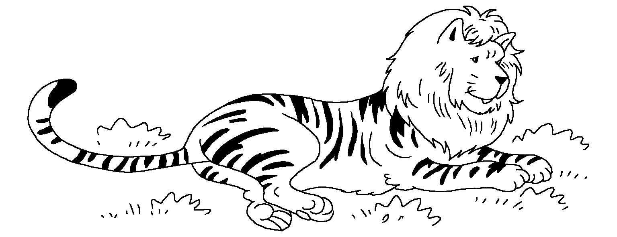

5

10

15

Choose the best answer by blackening the circle.

- What is a liger?
 A. a type of domestic cat
 B. a type of lion
 C. a type of tiger
 D. a mix between a lion and a tiger

- A liger can be as heavy as __________.
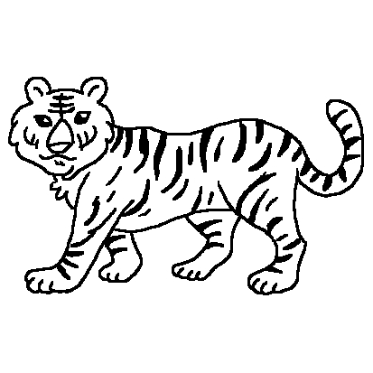 | 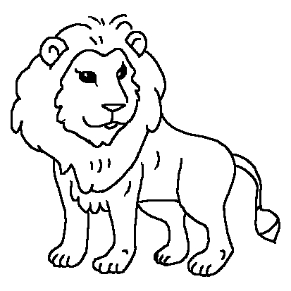 | 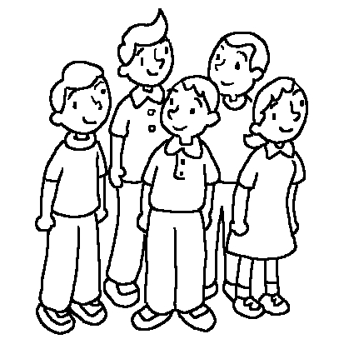 | 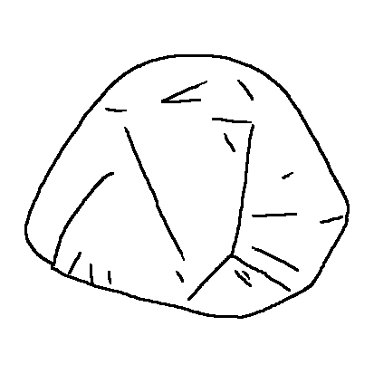
 A. |  B. |  C. |  D.

- Which of the following about ligers is true?
 A. They cannot swim.
 B. They look like leopards.
 C. They like living alone.
 D. They continue to grow and grow.

- Where can you find Hercules?
 A. in China
 B. in an animal theme park
 C. in a TV studio
 D. in a zoo

- Why is it hard to find ligers in a natural environment?
 A. Lions and tigers do not live in the same area.
 B. Lions are larger than tigers.
 C. Ligers only live in zoos.
 D. They cannot find food in a natural environment.

- Which of the following about tigons is NOT true?
 A. They are mixed animals.
 B. They are the heaviest animal in the world.
 C. Their mother is a lion.
 D. Their father is a tiger.

- Read line 17. What does the word ‘exceedingly’ mean?
 A. dangerously
 B. extremely
 C. surprisingly
 D. sadly
Part 4
Brian is reading an article about Thailand on a website.
Read the article.

http://www.lionair.com/travelguide/thailand

Main Page > Travel Guide > Asia > Thailand
Thailand

Thailand is a popular tourist destination. It is a great place for families to spend their holiday. Since Thailand is in the tropics, it is always hot and sunny. Most tourists visit Bangkok and Phuket when going to Thailand.
5
Bangkok is the largest city in Thailand. There are hundreds of temples in the city. The most famous one is Wat Arun, where the temple is over 70 metres tall. It is so famous that it can be seen on Thai coins. If you are interested in sea animals, you can visit the
Siam Ocean World. It is the largest aquarium in Southeast Asia.
10
There are many street markets in Bangkok. You can find a huge range of goods from cheap clothes to traditional handicrafts there. Inside the street markets, you can also try many delicious local snacks.

For those of you who enjoy relaxation and nature, Phuket would be a great destination. It is located south of Bangkok. You will find many lovely beaches and beautiful hotels there. You can also enjoy water sports such as swimming, diving and riding water motorcycles.
15

Lion Air flies daily to Bangkok. We also fly to Phuket every Tuesday, Thursday and Sunday. Fly with us to Thailand and enjoy a great holiday there!
20

Choose the best answer by blackening the circle.

- What is the weather like in Bangkok?
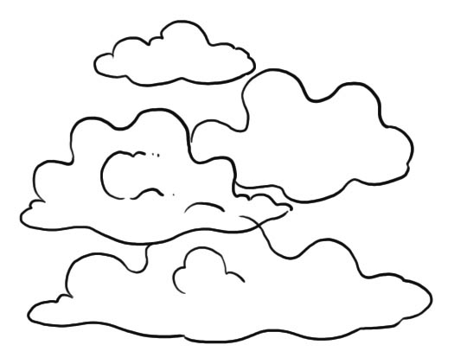 |  |    | 
 A. |  B. |  C. |  D.

- Which of the following can be found on a Thai coin?
 | 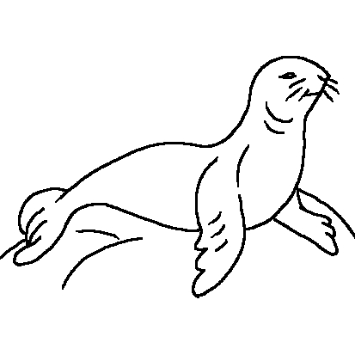 | 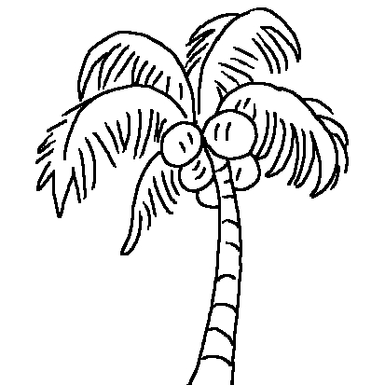 | 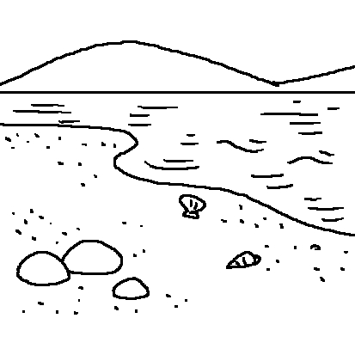
 A. |  B. |  C. |  D.

- What is NOT in the Siam Ocean World?
 |  | 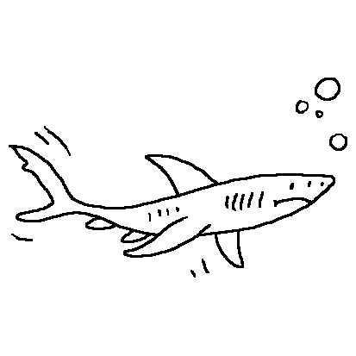  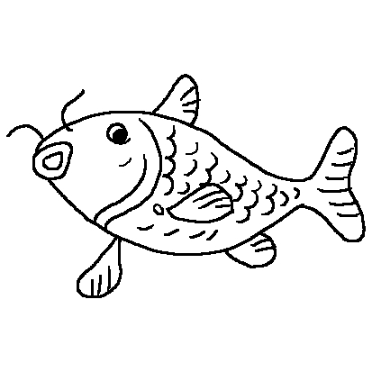 | 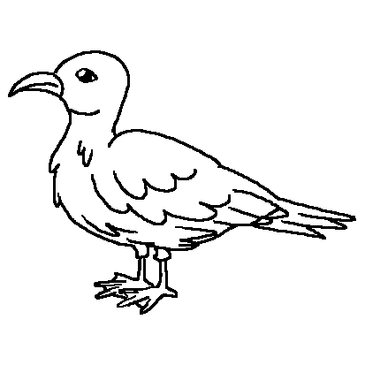
 A. |  B. |  C. |  D.

- Which of the following is true about the street markets?
 A. You cannot eat or drink inside.
 B. You can only buy clothes and handicrafts there.
 C. You can buy many things there.
 D. There are three street markets in Bangkok.

- Which of the following about Bangkok is NOT correct?
 A. There are many temples.
 B. There are many theme parks.
 C. There are many street markets.
 D. It is the largest city in Thailand.

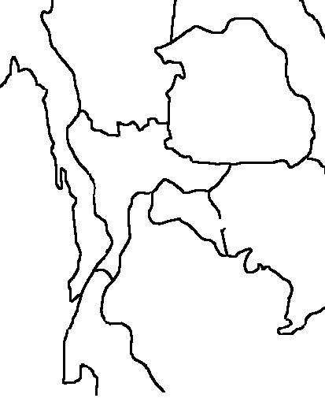
- Where is Phuket?
Phuket
Bangkok
Bangkok  Phuket | Phuket  Bangkok | Phuket  Bangkok
 A. |  B. |  C. |  D.

- ‘Lion Air’ is ____________.
 A. an airline
 B. an animal
 C. a hotel
 D. a water sport
Part 5
Brian wants to visit Thailand. He brings home some leaflets.
Read the leaflets.

Smart Travel  Bangkok 4-day Tour  Price: $4,000 per adult  $3,500 per child under 12  Attractions:  Day 1: Wat Arun Temple  Siam Ocean World  Day 2: National Museum  The Queen’s Gallery  Day 3: Fantastic World Theme Park  Day 4: Shopping at street markets  Hotel: Tiger Hotel  *A special Thai buffet will be provided. | Pegasus Travel  Bangkok 3-day Tour  Price: $2,500 per adult  $2,000 per child under 12  Attractions:  Day 1: Wat Arun Temple  National Museum  Day 2: Queen Saovabha Snake Farm  The Queen’s Gallery  Day 3: Shopping at street markets  Hotel: Southern Hotel  *Breakfasts will be provided.
May Flower Travel  Bangkok and Phuket 4-day Tour  Price: $4,500 per adult  $4,000 per child under 12  Attractions:  Day 1: Wat Arun Temple  Siam Ocean World  Day 2: Shopping at street markets  Flight to Phuket  Day 3: Coconut Island  Day 4: Free time  Hotels: Johnson Hotel (Bangkok)  Seashore Hotel (Phuket)  *Meals will be provided. | Sunshine Travel  Phuket 4-day Tour  Price: $4,200 per person  $3,700 per child under 12  Attractions:  Day 1: Free time  Day 2: Coconut Island  Fishing on traditional boat  Day 3: Kamala Beach  Day 4: Thai Boxing Show  Free time  Hotel: Crystal Palace Resort Hotel  *No meals will be provided.
Choose the best answer by blackening the circle.

- Brian is 11 years old. He wants to join the Bangkok 4-day Tour with his parents. How much do they need to pay?
 A. $10,500
 B. $11,000
 C. $11,500
 D. $12,000

- What will Brian NOT see if he joins the Bangkok 3-day Tour?
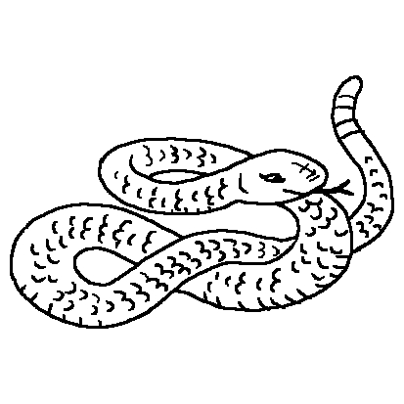 |  | 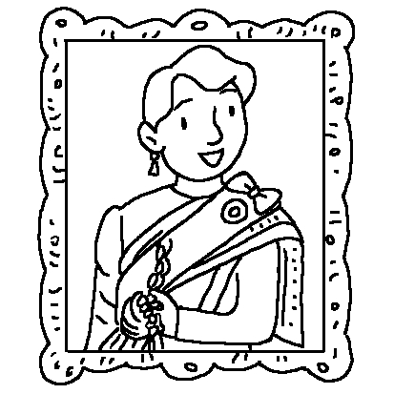
 A. |  B. |  C. |  D.

- What will Brian do on the second day if he joins the tour by May Flower Travel?
 A. visit a temple
 B. see some snakes
 C. fly to Phuket
 D. visit Coconut Island

- Which of the following is in the Fantastic World Theme Park?
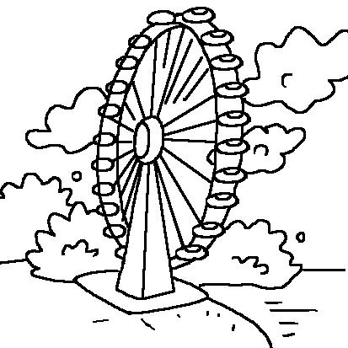 |  |  | 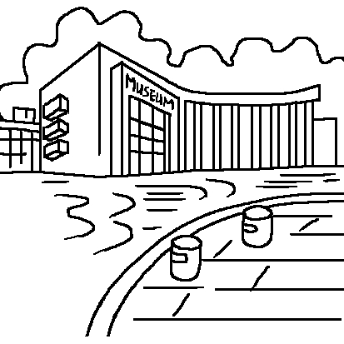
 A. |  B. |  C. |  D.
- Which company offers the shortest tour?
 A. Smart Travel
 B. Pegasus Travel
 C. May Flower Travel
 D. Sunshine Travel

- Which hotel is NOT in Bangkok?
 A. Johnson Hotel
 B. Southern Hotel
 C. Tiger Hotel
 D. Crystal Palace Resort Hotel

- Which of the following is NOT correct?
 A. Children are charged $500 less for all tours.
 B. Coconut Island is in Phuket.
 C. Tourists can enjoy free time in the Phuket 4-day Tour only.
 D. The Bangkok 3-day Tour is the cheapest.

Part 6
Brian is writing a letter to his pen-friend.
Read Brian’s letter.
Dear James,

How are you? Is it rainy in London? The weather is fine here, so I can play basketball with my friends. Do children in England like playing basketball?

My school is organising a book report competition. I want to join the competition. I am still deciding which book to write about. Do you know how to write a good book report?

I think I will write the book report on my favourite detective story. I enjoy reading detective stories! Sometimes I read science books, too. Last week, I read a book called Ants and Flies in Indonesia. There were pictures of ants, flies and spiders in it! They looked scary but it was fun to read about them. What books do you like reading?

I went to Thailand with my parents just before the new school year began. We stayed there for four days. It was great fun. We had a lot of activities there. We saw beautiful temples and statues of Buddha. We went swimming at the beach. I tried windsurfing and Dad tried fishing. We had some yummy Thai food too. Dad tried some red seafood soup. However, he did not let me try it because there were too many chillies in it! We bought many things like snacks, tablecloths, T-shirts … I have a small surprise for you. I hope you will like it.

What have you been doing lately? How did you spend your holiday? If you have time, do make a trip to Hong Kong. I am sure you will like the things and people here. I will show you my home, my school, my favourite places … and I will take you to the street food stalls in Mong Kok to try the yummy local snacks, too!

Write soon.

Love,
Brian

5
10
15
20
25
Choose the best answer by blackening the circle.

- Which book would Brian probably like?
 A. The History of Japan
 B. Pam’s New farm
 C. Cooking Fish Fillets
 D. The Invisible Robber

- Ants and Flies in Indonesia is a book about _________.
 A. insects
 B. fish
 C. pets
 D. birds

- When did Brian go to Thailand?
 A. in April
 B. in August
 C. in September
 D. in December

- What was in Brian’s father’s soup?
 A. chicken and eggs
 B. pork and beef
 C. fish and crabs
 D. apples and oranges

- Which of the following is true?
 A. Brian went fishing and swimming.
 B. Brian went fishing and visited temples.
 C. Brian went swimming and visited temples.
 D. Brian went swimming and ate seafood soup.

- Why did Brian’s father NOT let him try the soup?
 A. It was too salty.
 B. It was too sweet.
 C. It was too bitter.
 D. It was too spicy.

- Read line 20. Brian wrote: ‘I have a small surprise for you!’
What is the ‘small surprise’?
 A. a souvenir
 B. a small bomb
 C. a book report
 D. a spider

- Read line 24. Brian wanted James to try some ‘yummy local snacks’. What might they be?
 A. chillies
 B. curry fish balls
 C. Thai seafood soup
 D. sushi

Part 7
James is writing a reply letter to Brian. Help him complete the letter.
You are James. Look at the pictures and write the letter in about 80 words.

1.  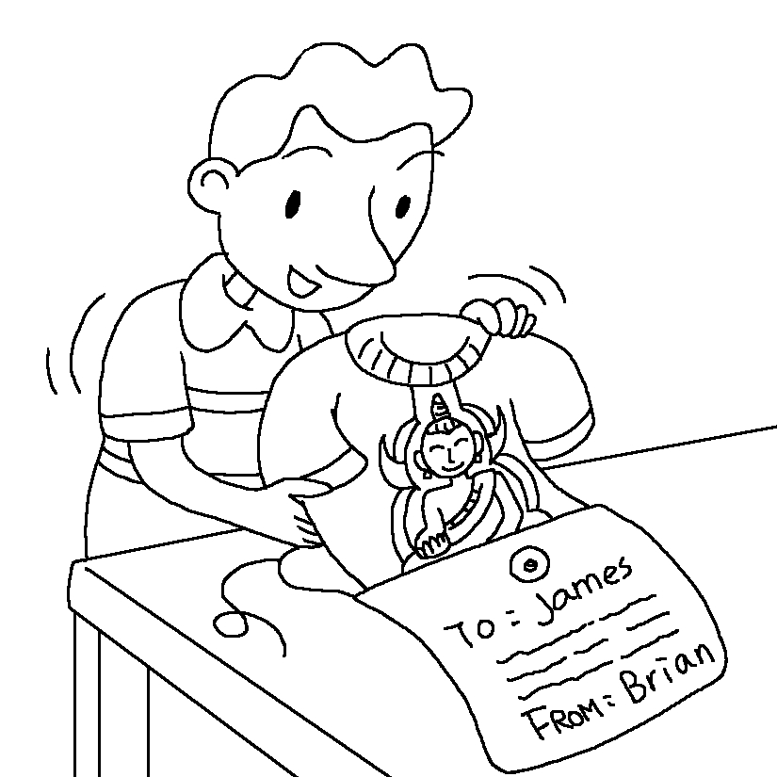 | 2.  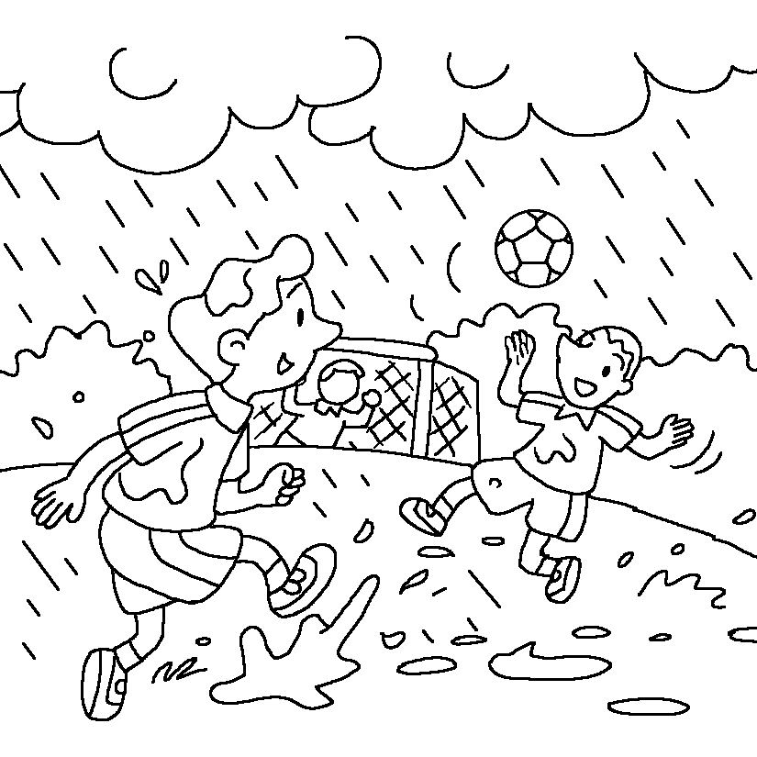
3.  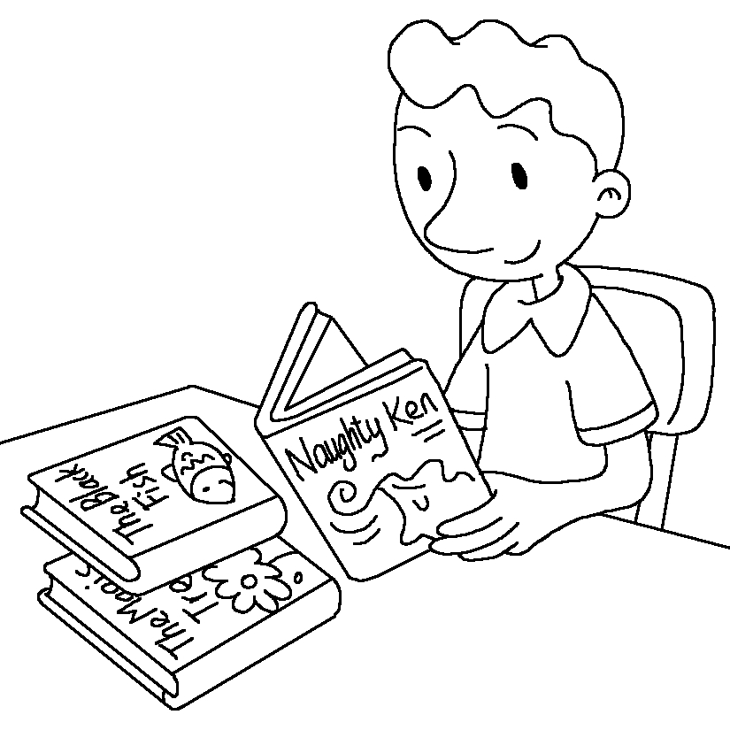 | 4.  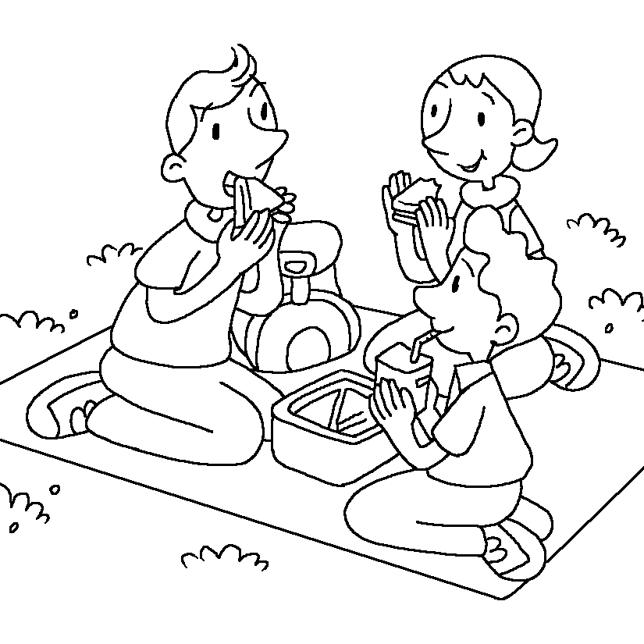

Dear Brian,

I am doing well here. __________________________________________________
________________________________________________________________
________________________________________________________________
________________________________________________________________
________________________________________________________________
________________________________________________________________
________________________________________________________________
________________________________________________________________
________________________________________________________________
________________________________________________________________

Write soon.

Love,
James

END OF PAPER

